Results based on image analysis for the improvement of food production+ irrigation+ disease identification

https://www.researchgate.net/publication/352970368_Computer_Vision_Framework_for_Wheat_Disease_Identification_and_Classification_Using_Jetson_GPU_Infrastructure

Our main objective was to automate plant-disease identification using advanced deep learning approaches and image data.

=>From the experimental results, the VGG19 model classified wheat disease with 99.38% accuracy.

https://link.springer.com/article/10.1007/s11119-023-10009-9?utm_source=xmol&utm_medium=affiliate&utm_content=meta&utm_campaign=DDCN_1_GL01_metadata

Optimization strategies of fruit detection to overcome the challenge of unstructured background in field orchard environment: a review
(best of all)

Yu et al. (2019) used a Mask R-CNN model to detect and segment strawberries growing in an unstructured environment and locate their picking points. The overall accuracy and recall were 95.78 and 95.41, respectively.

The research of Jia et al. (2020) on detecting and segmenting green apples demonstrated that the proposed recognition method yielded the best detection performance for unobstructed fruits

Fruits with different degrees of maturity can be detected by object detection.

The algorithm achieves a 100% detection accuracy for apples that are completely visible on the fruit tree and more than 80% for occluded apples, with respective false detection rates of 0% and 1%

Common backbone network improvement strategies include the following: (1) adjusting the depth and width of the backbone network; (2) integrating with other backbone networks; (3) embedding other structural units.

https://www.azorobotics.com/Article.aspx?ArticleID=405

Experts Develop Multi-Scale Plant Disease Detection Model (* Good paper)
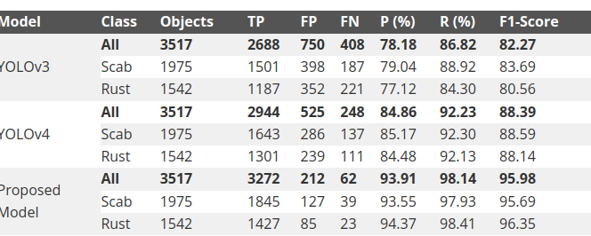

An Efficient Real-Time Weed Detection Technique using YOLOv7
https://thesai.org/Downloads/Volume14No2/Paper_65-An_Efficient_Real_Time_Weed_Detection_Technique.pdf
Experimental results revealed that the YOLOv7 model achieved the mAP@0.50, f1score, Precision, and Recall values for the bounding boxes as 99.6,97.6, 99.8, and 95.5 respectively on the early crop weed dataset and 78.53, 79.83, 86.34, and 74.24 on 4weed dataset.
The mAP@0.5 detection accuracy for the early crop weed dataset is 99.6 while the mAP@0.5 detection accuracy for the 4weed dataset is 78.53.

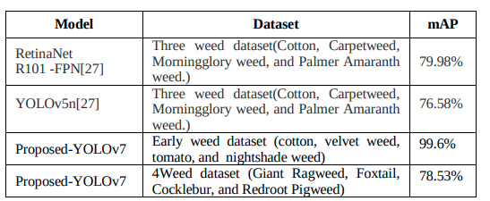

https://arxiv.org/pdf/2304.04966.pdf

Optimization strategies of fruit detection to overcome the challenge of unstructured background in field orchard environment: a review
For binary class, the supervised and semi-supervised training models had an equal mAP@.5 of .89 (Figure 6A), showing similar performance for both methods. However for multi-class detection (Figure 6B), the mAP@.5 was 0.77 in case of semi-supervised model, which was only 0.6 with the supervised method.

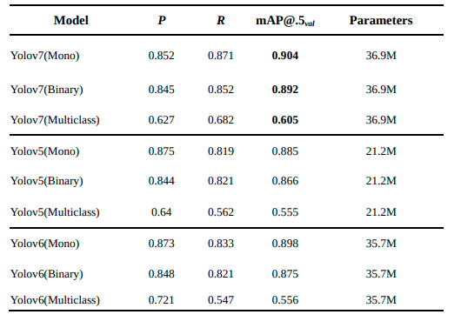
https://www.mdpi.com/2624-7402/5/1/27

Accuracy Comparison of YOLOv7 and YOLOv4 Regarding Image Annotation Quality for Apple Flower Bud Classification

A 0.80 mAP was achieved by YOLOv7 with 100% training image annotation quality, meanwhile a 0.63 mAP was achieved with only 5% training image annotation quality.

https://www.sciencedirect.com/science/article/pii/S2589721722000174

Deep learning based computer vision approaches for smart agricultural applications

3600

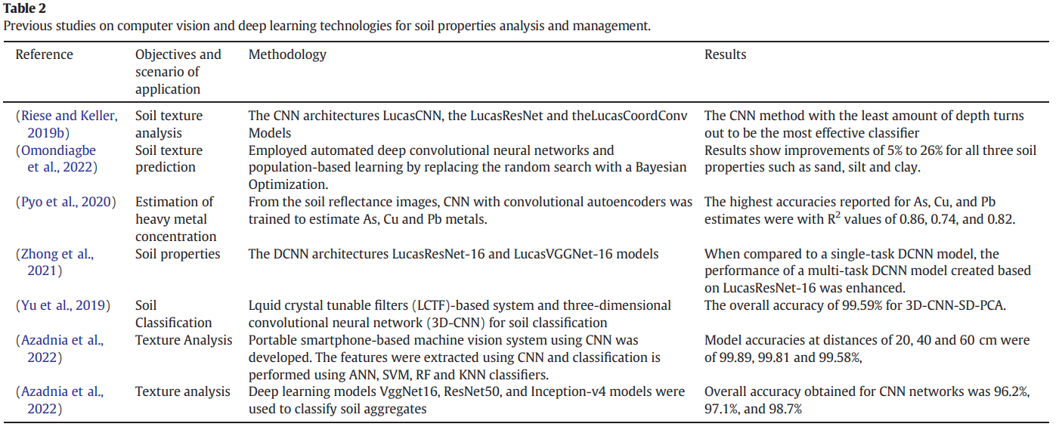

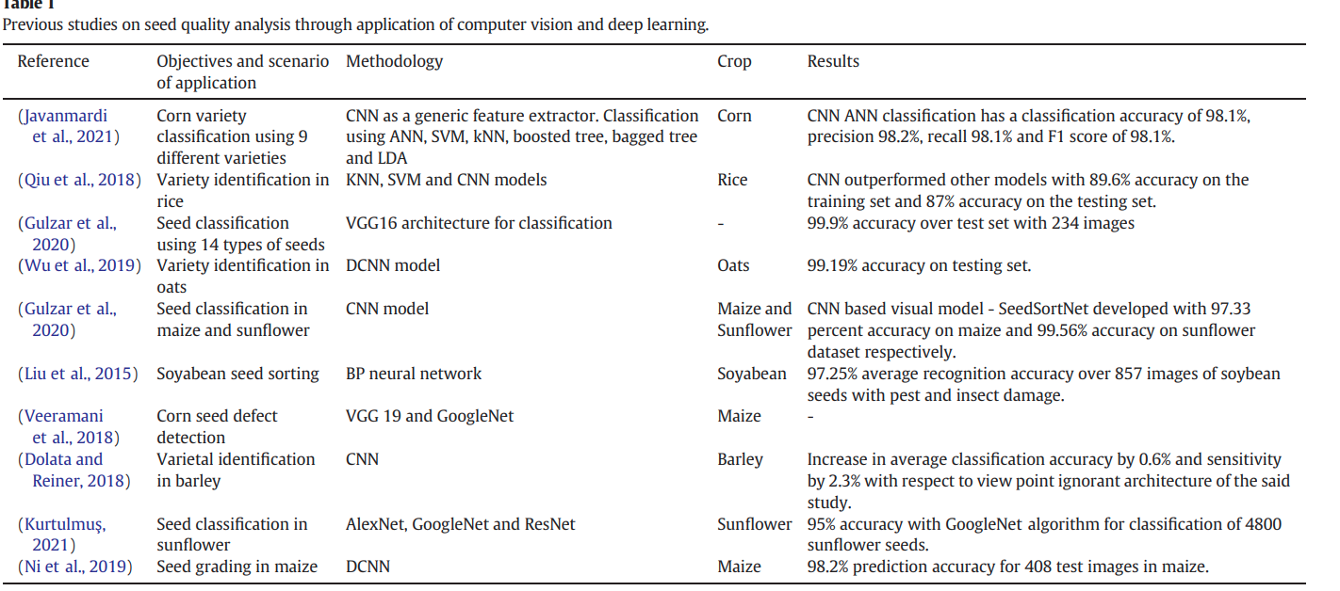

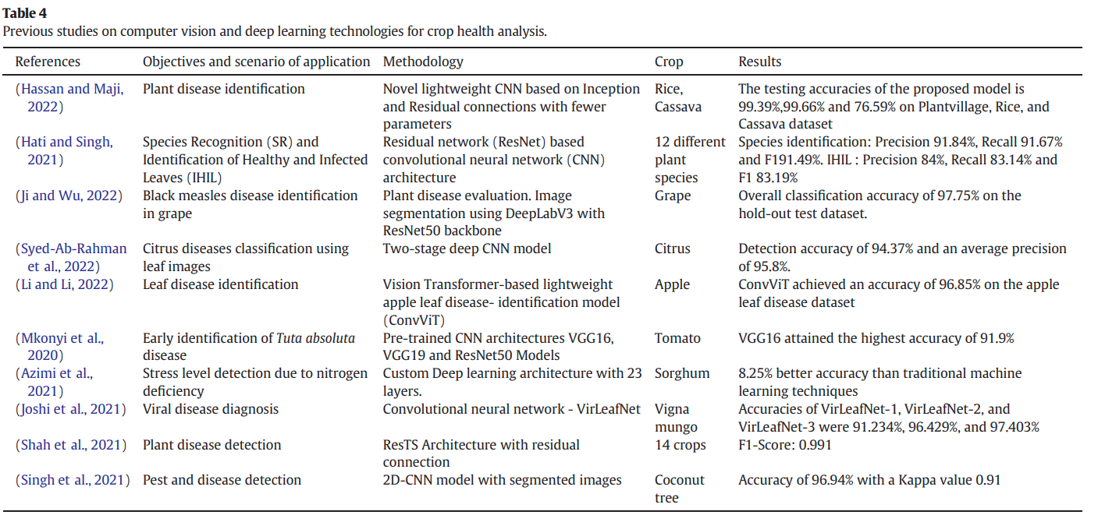

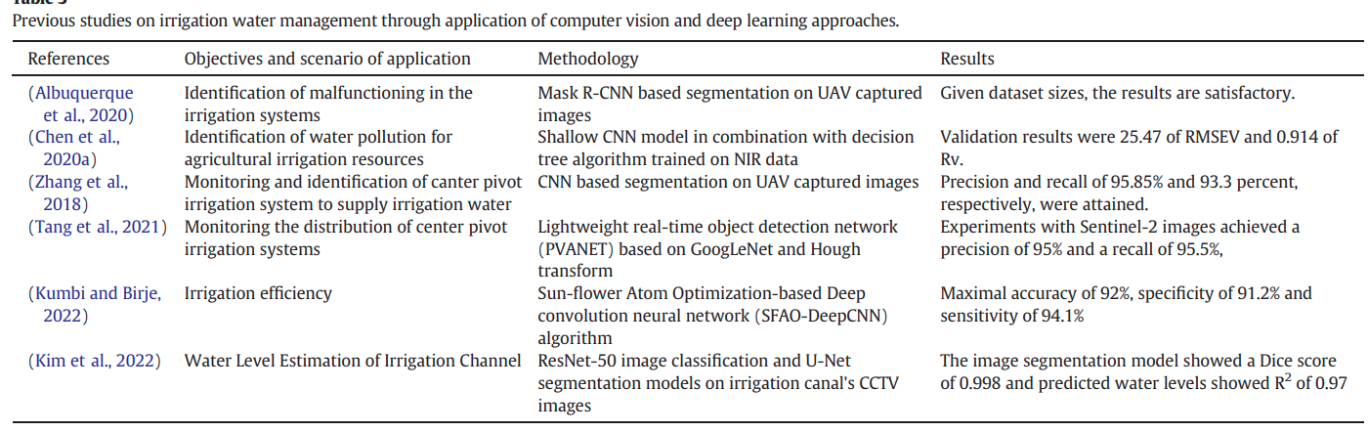

*************

https://www.mdpi.com/2073-4395/13/3/639

Object Detection and Recognition Techniques Based on Digital Image Processing and Traditional Machine Learning for Fruit and Vegetable Harvesting Robots: An Overview and Review

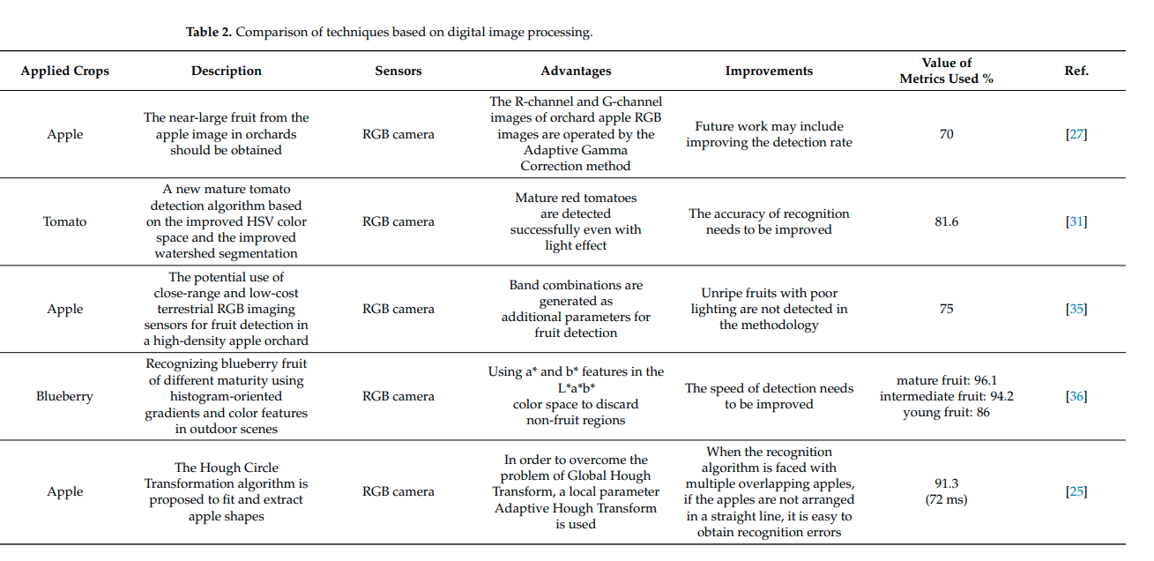
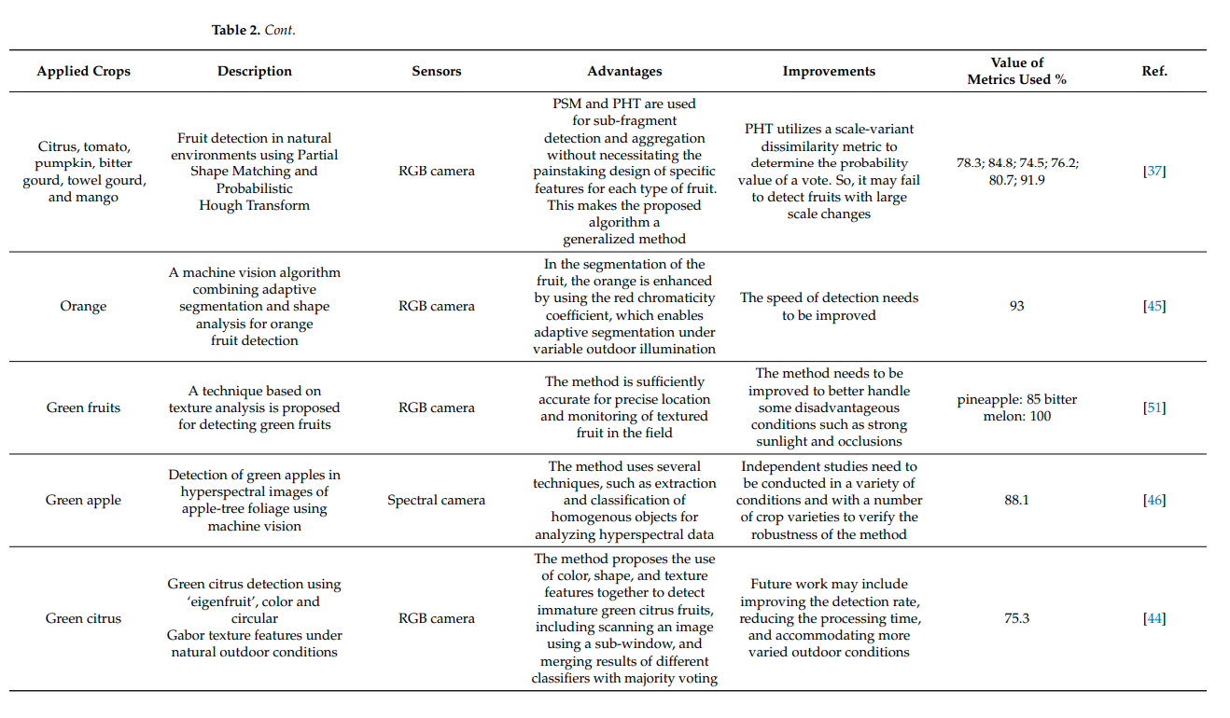

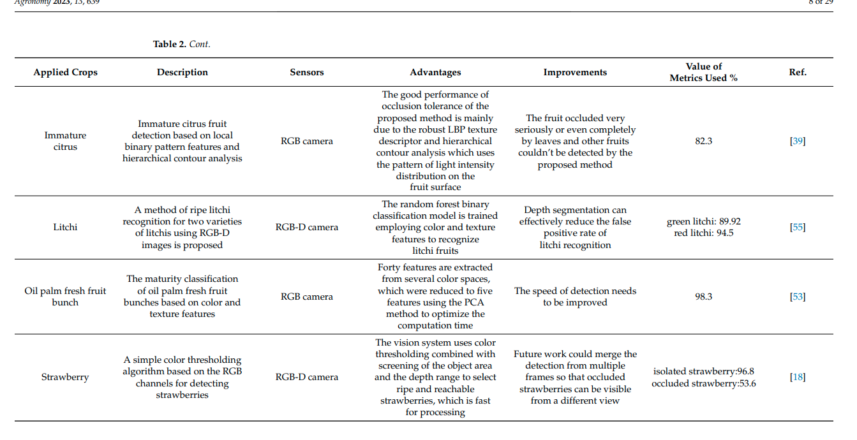

2)

TIA-YOLOv5: An improved YOLOv5 network for real-time detection of crop and weed in the field

https://www.frontiersin.org/articles/10.3389/fpls.2022.1091655/full

Data:
Chebrolu et al., 2017) sugarbeet dataset

model: TIA-YOLOv5, pixel-level synthesization method

Result:

F1-scoreweed, APweed and mAP@0.5 were improved to 61.0%, 77.7% and 88.4%

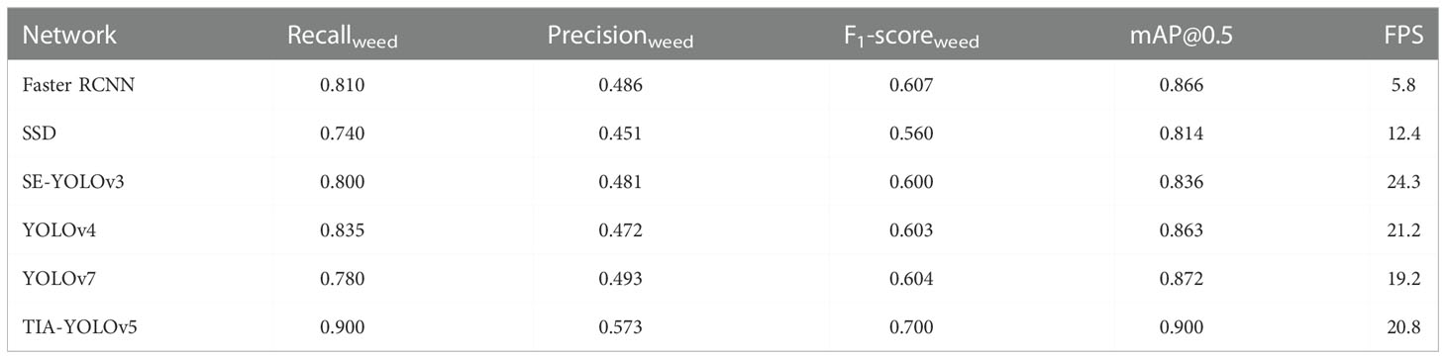

My Analysis and conclusion:

Image analysis for the improvement of food production+ irrigation+ disease identification/

- Object detection model can be used to identify, detect, and analyze plant disease
- Real time tracking of environmental conditions
- Object detection model can be used to identify, detect, and analyze growth of food.
- Live tracking of pests, weed growth
- Monitoring Plant Health
- Water Management

2)
Multiple disease detection method for greenhouse-cultivated strawberry based on multiscale feature fusion Faster R_CNN

https://www.sciencedirect.com/science/article/pii/S0168169922004938#b0095

model:
ResNet-50 as the Faster R_CNN backbone

Result:

map 92.18%

****************** 2305 ******************
1)

REAL TIME PEST DETECTION USING YOLOv5

https://www.researchgate.net/publication/357516853_REAL_TIME_PEST_DETECTION_USING_YOLOv5/link/61d1e52ed450060816850cc6/download

Data:

? Data is not so clear / A lot of data preparation is required

https://universe.roboflow.com/simon-roge/caterpillars-hrd2x/dataset/2

https://data.mendeley.com/datasets/bycbh73438/1

Results:
Model: YOLOv5m

Precision=0.746 Recall =0.686 mAP @IoU :0.5= 0.591

